Name :- Piyush Sunil Patil
Roll No :- 143
Practical :- 01
Practical Name :- Set up a GitHub account and send an email a message to friend telling to your friend about the account

Create a GitHub account:-

if you don’t already have a GitHub account,here’s how to create one.

1.Open https://github.com in a web browser and select the sign up.
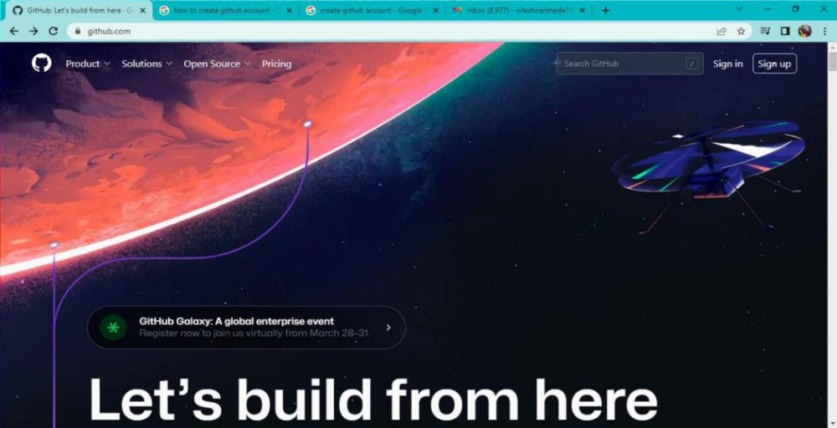
2. Enter the email address
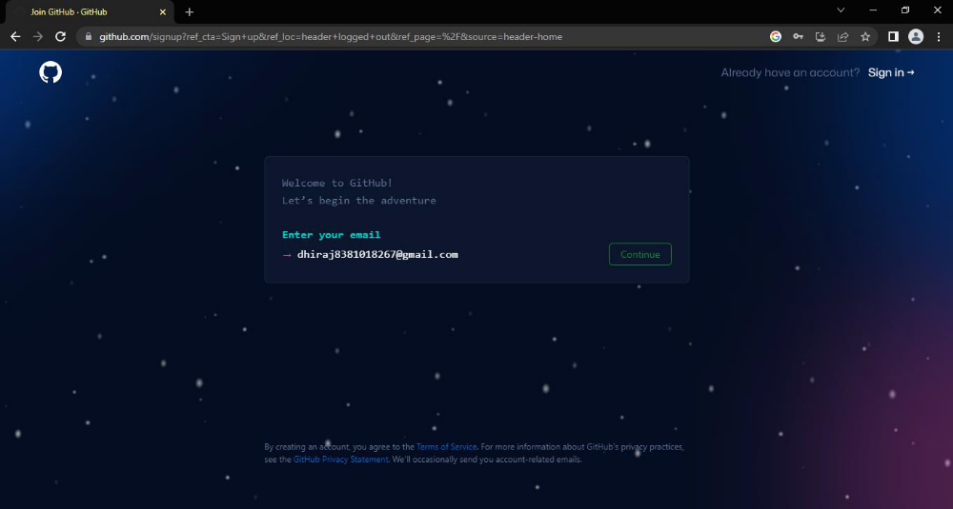
3. Create a password for your new GitHub account, and Enter a username ,too. Next choose whether you want to receive update and announcements via email,and then selwct continue.
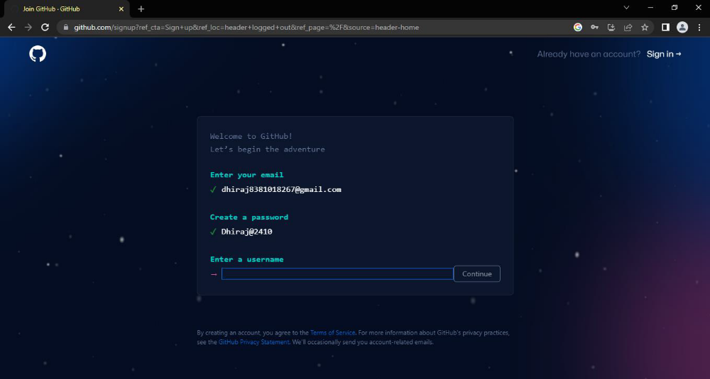

4. Enter the username

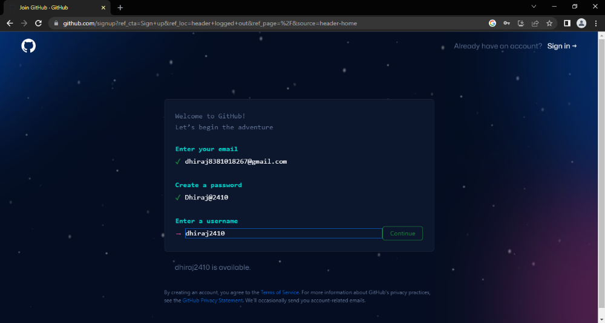

5. Would you like to receive product updates and announcements via email? Type "y" for yes or "n" for no

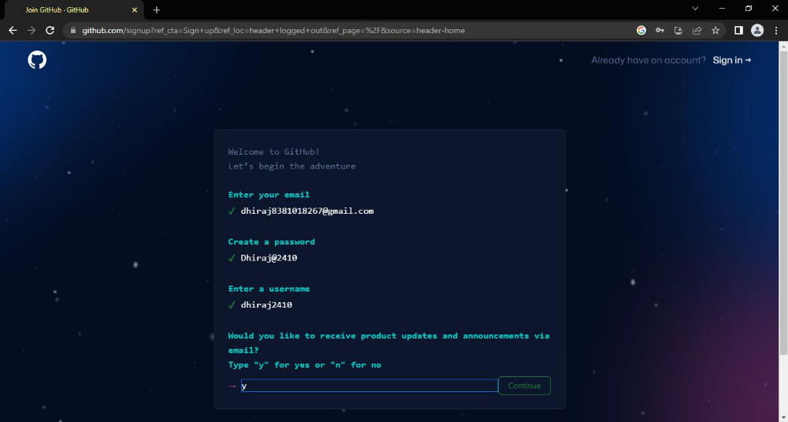

6. Verify your account by solving a puzzle .select the start puzzle button to do so, and then follow then follow the prompts.
7. After you verify your account, select the create account button.

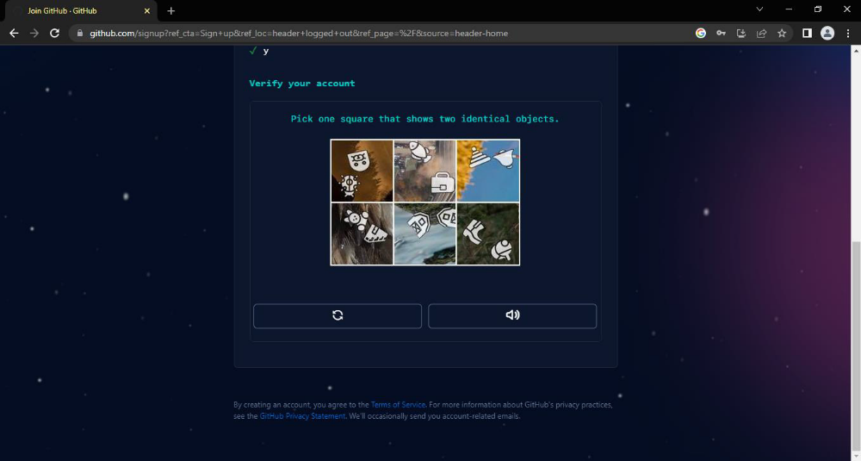

8. Next, GitHub send a launch code to your email address. Type that launch code in the enter code dialog , and then press enter.

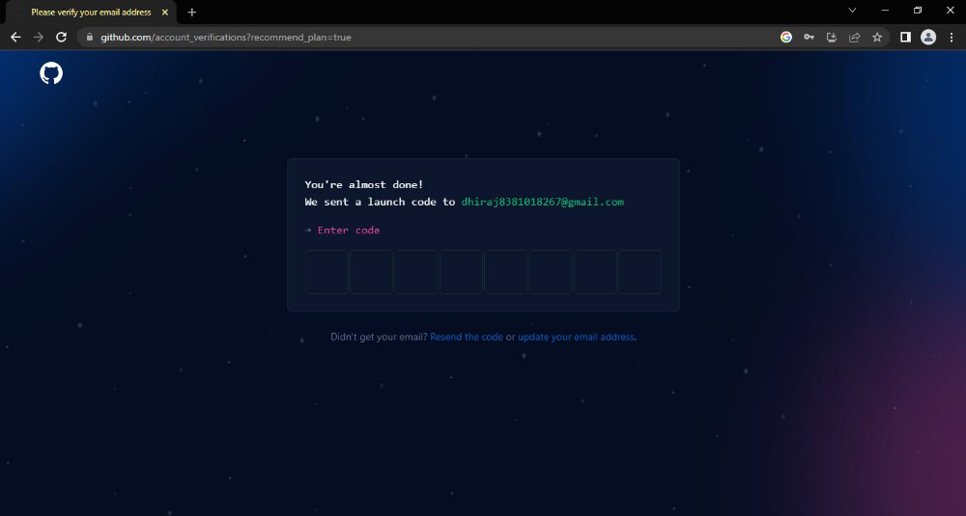

9. GitHub asks you some questions to help tailor your experience. choose the answer that apply to you in the following dialogs:
o How many team members will be working with you?
o What specific feature are you interested in using?

10. On the where team collaborate and ship screen,you can choose whether you want to use the free account or the team account. To choose the free account ,select the skip personalization button.
GitHub opens a personalized page in your browser.
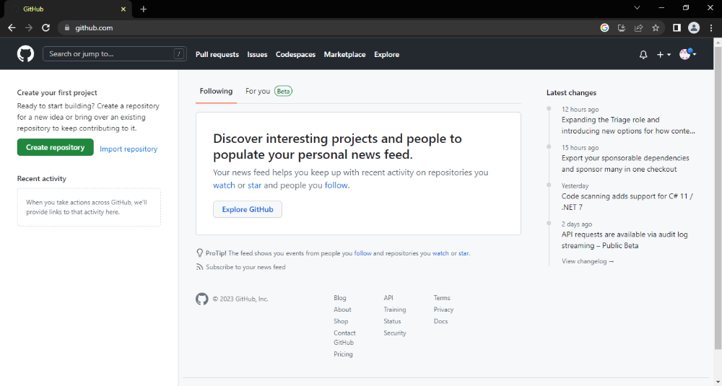

Congratulations! You’ve successfully created your GitHub account.
Paste the screen shots of email which you had sended to your friend through GitHub.
